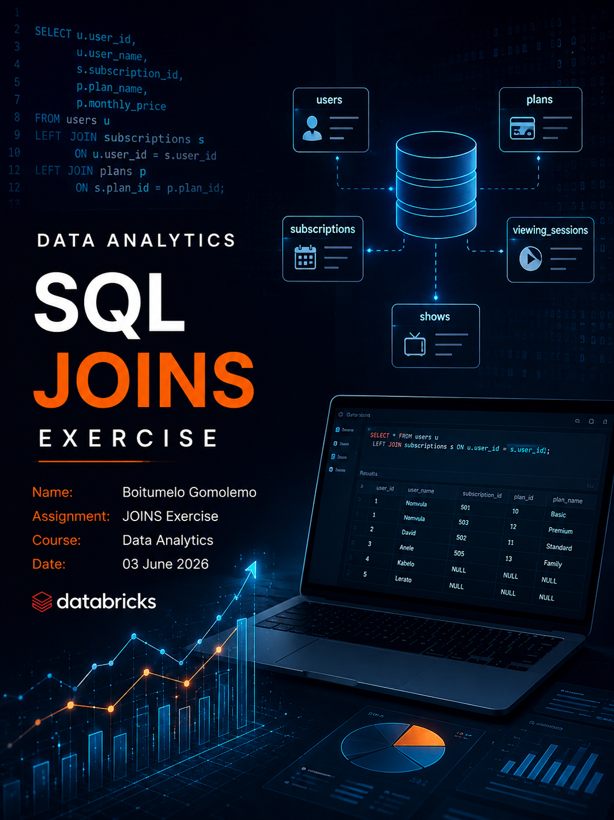

SQL Environment Used:
Databricks SQL Editor
GitHub Repository: boitygee-coder/JOINS-exercise: Doing INNER JOINS, LEFT JOINS and FULL OUTER JOINS from databricks and syncing the exercise with GitHub
Creating Tables in Databricks
Table 1: users
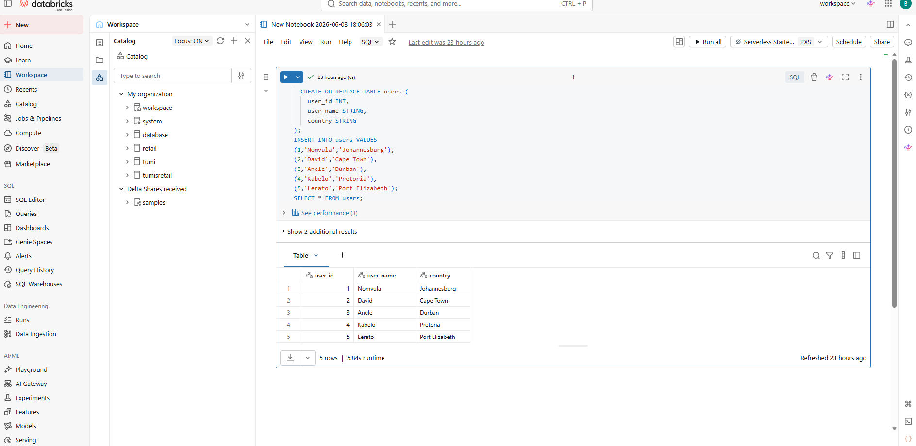

Table 2: plans
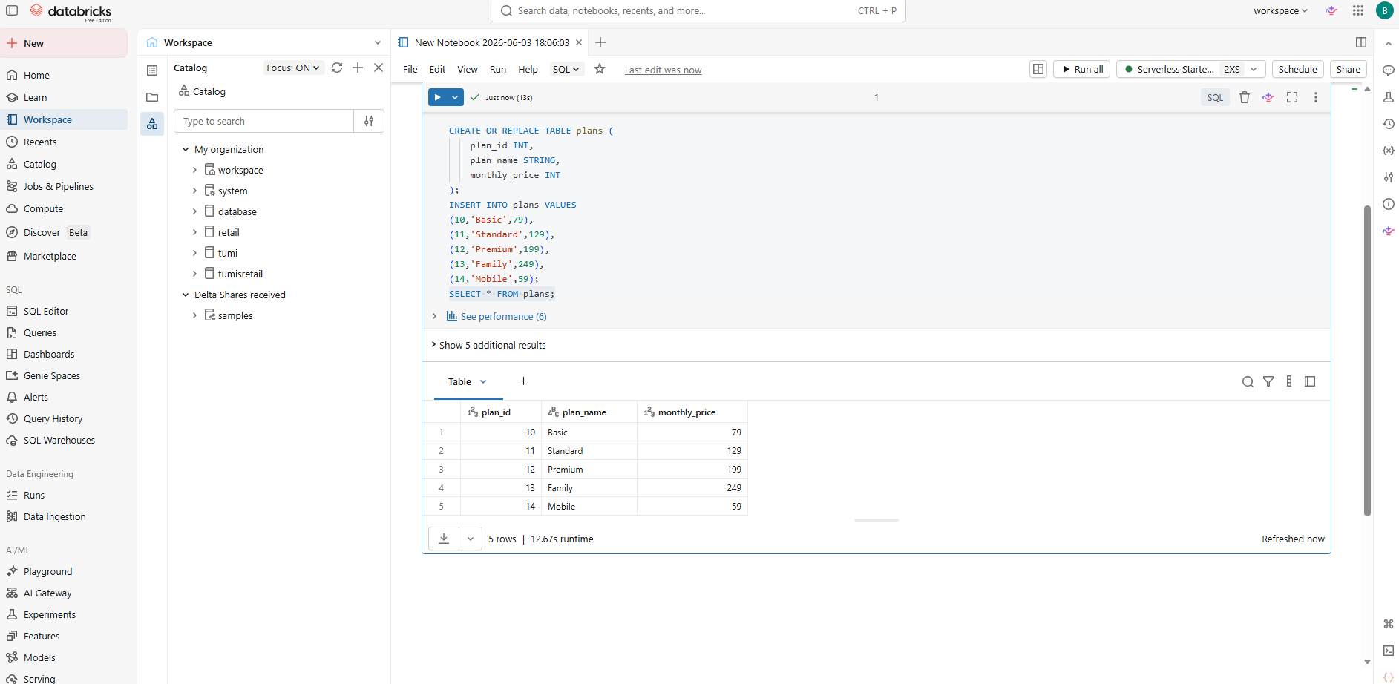
Table 3: subscriptions
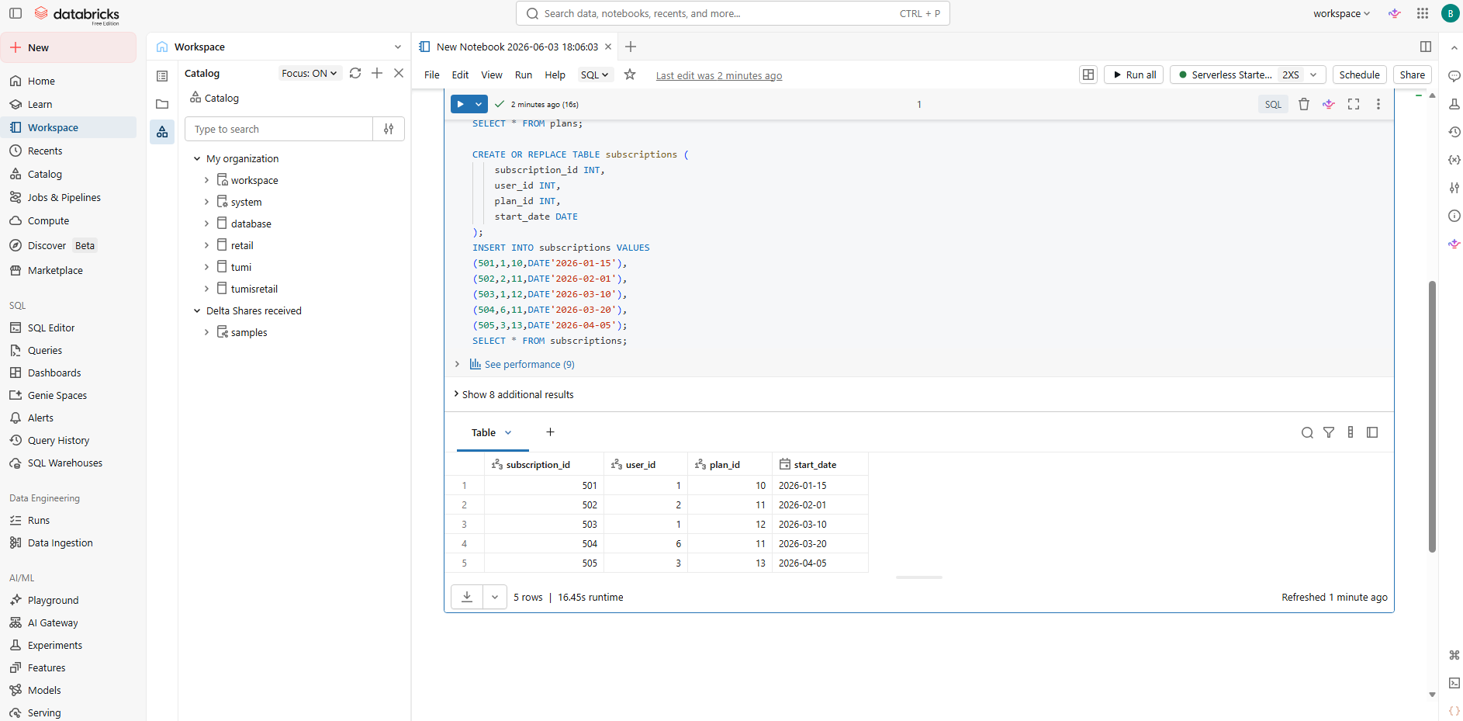
Table 4: shows
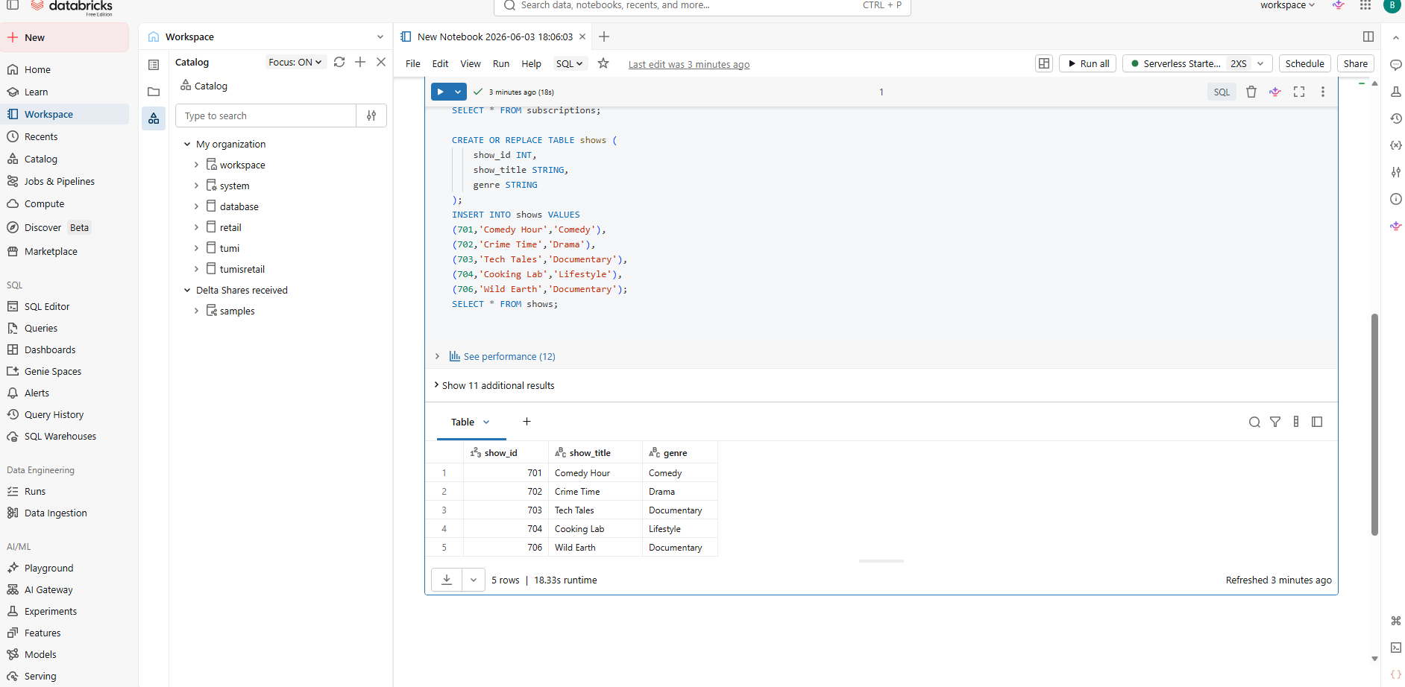

Table 5: viewing sessions
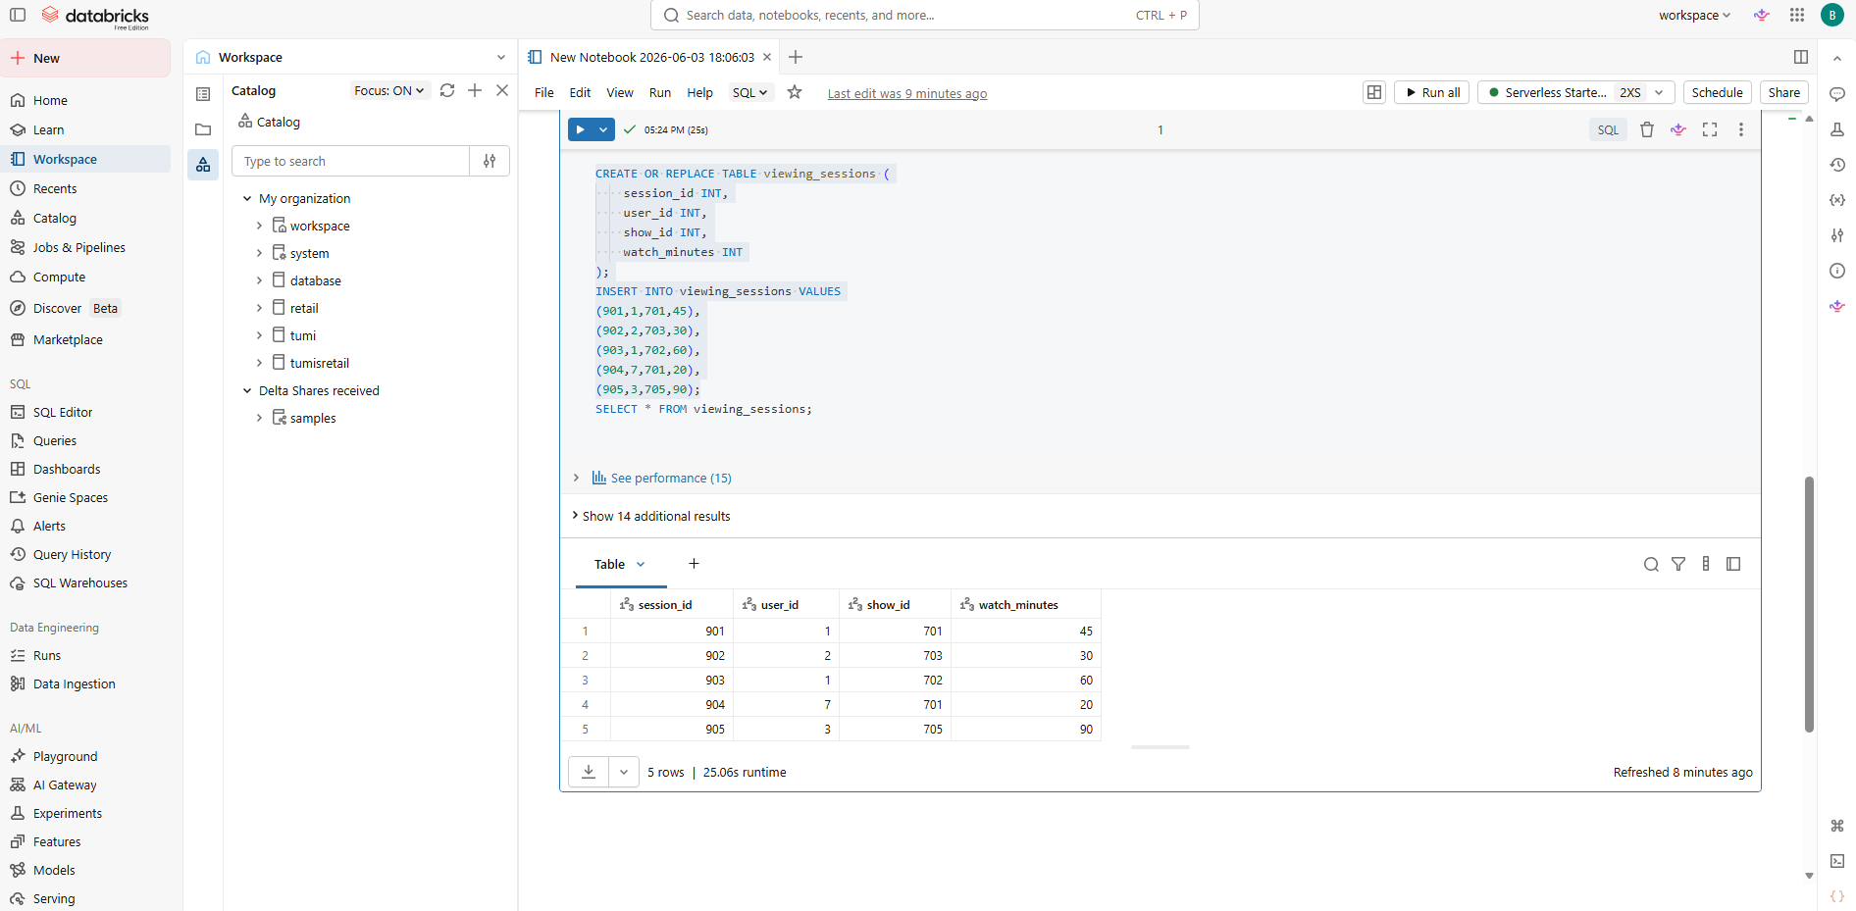
PART A: INNER JOIN
Question 1
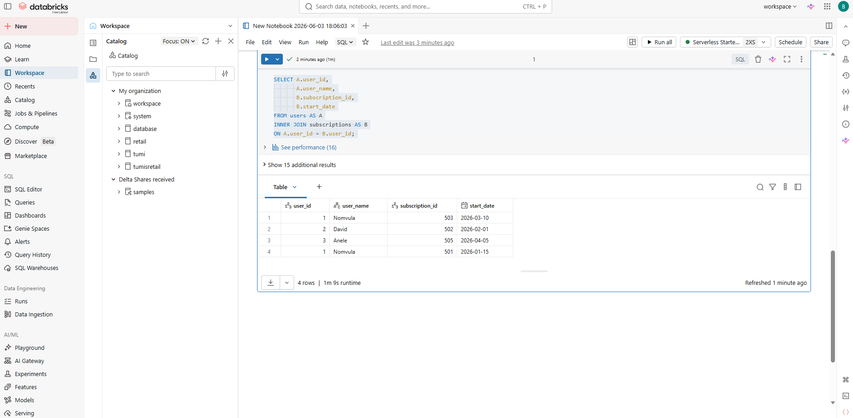
The table shows all users with subscriptions plans but user 4 and 5 have no subscription hence they are missing from the table.
Subscription 504 references user 6 who is not included in the table as well because he is not in the users table.

Question 2
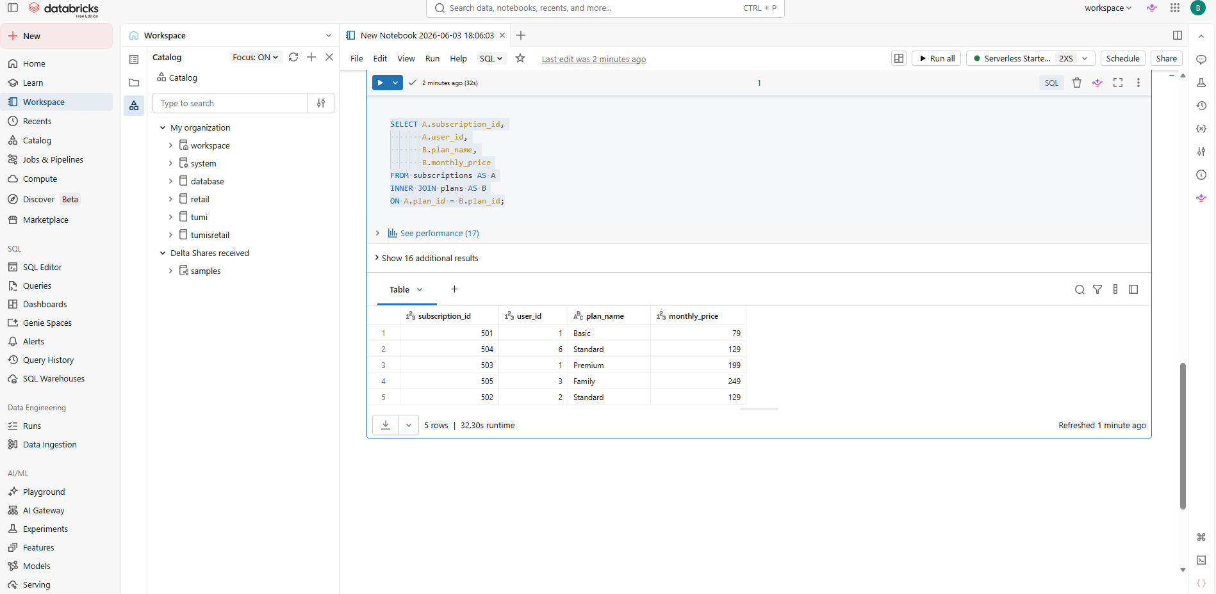
Table 2 shows subscription with its matching plan, name and monthly price but plan 14 has no subscription hence it is missing from the table.
Question 3
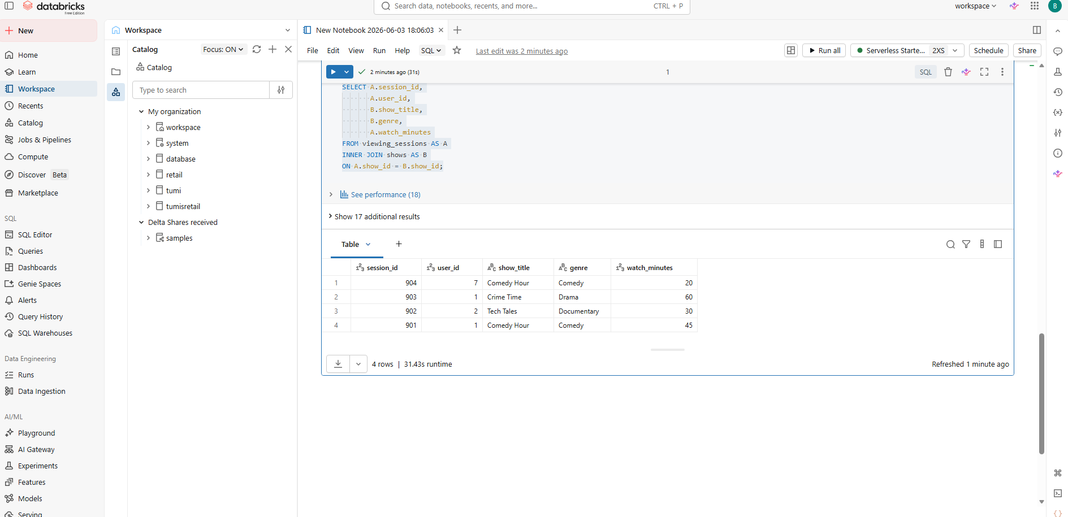
Table 3 shows every session that has a matching show. Show 704 and 706 have no watching minutes hence they are excluded in the table, and session 905 has no show hence it is also excluded from the table.

Question 4
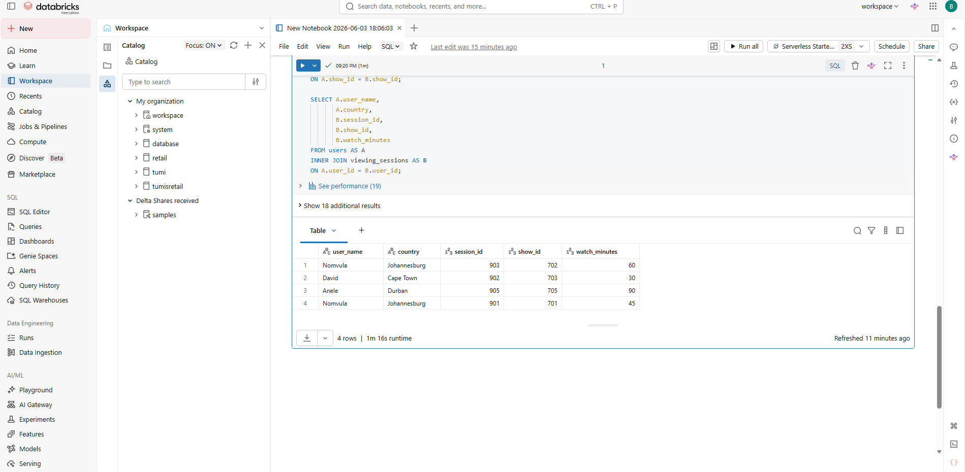
Table 4 shows all the users with viewing session, user 4 and 5 have no viewing sessions hence they are excluded from the table. Session 904 which references user 7, who is not included in users table is also excluded from the table.
Question 5
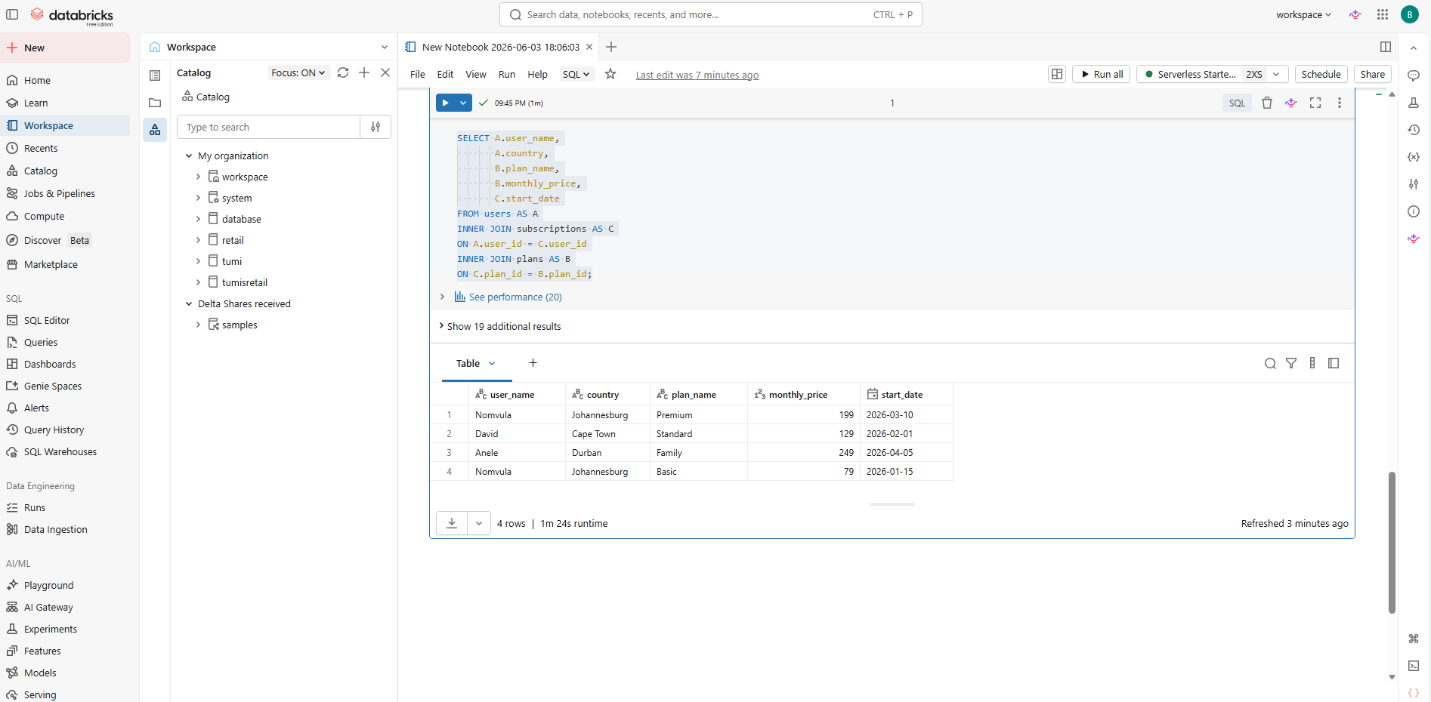
Table 5 shows users with subscription plans, their names and prices only. Lerato and Kabelo don’t have plans and mobile plan has no users, hence they are excluded from the table.

PART 2 – LEFT JOIN
Question 6
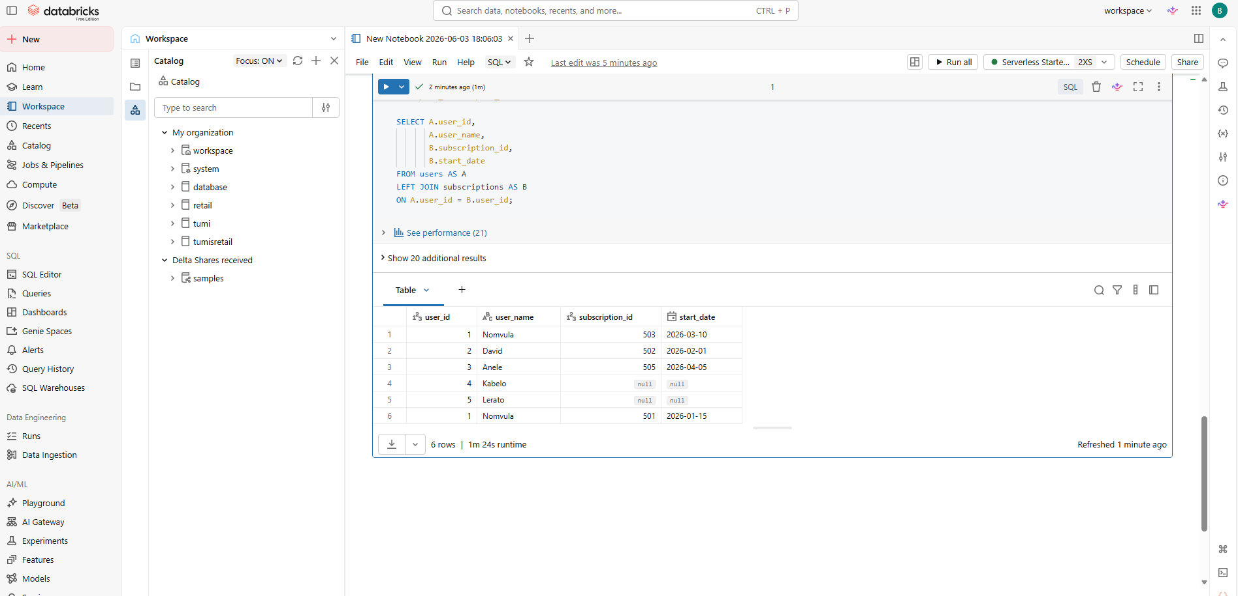
Table 6 shows all the users with their subscription plans even the ones without the plan are included in the table and it shows NULL to show they have no subscription plans. Nomvula (user 1) has two subscription plans and they are all shown because they are different plans.
Question 7
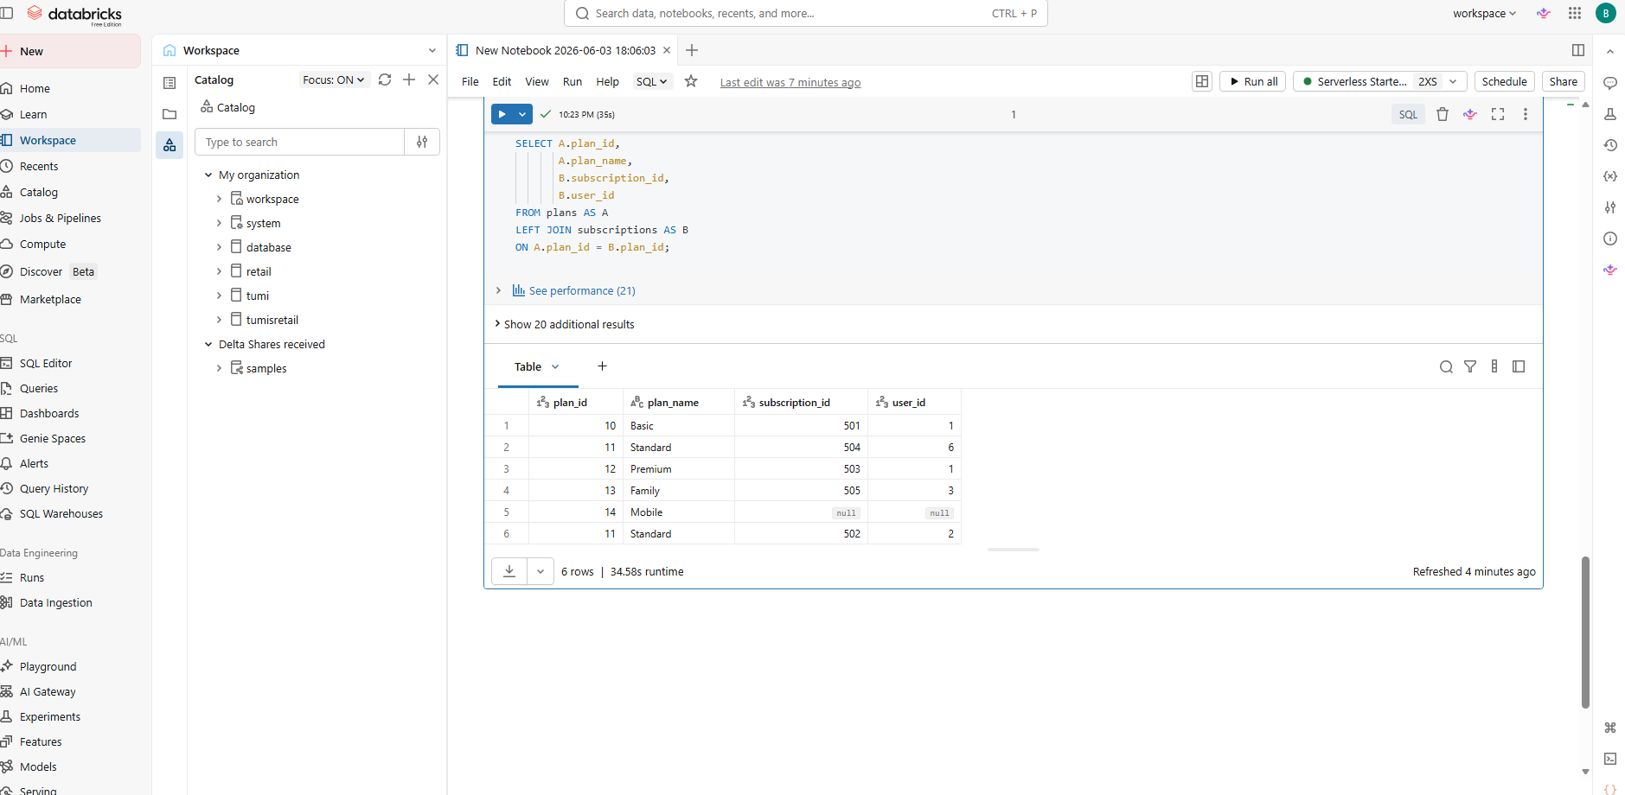
Table 7 shows all the plans even the ones without subscribers, Mobile plan has no subscribers but it is still included in the table however it show NULL for subscription_id and user_id.

Question 8
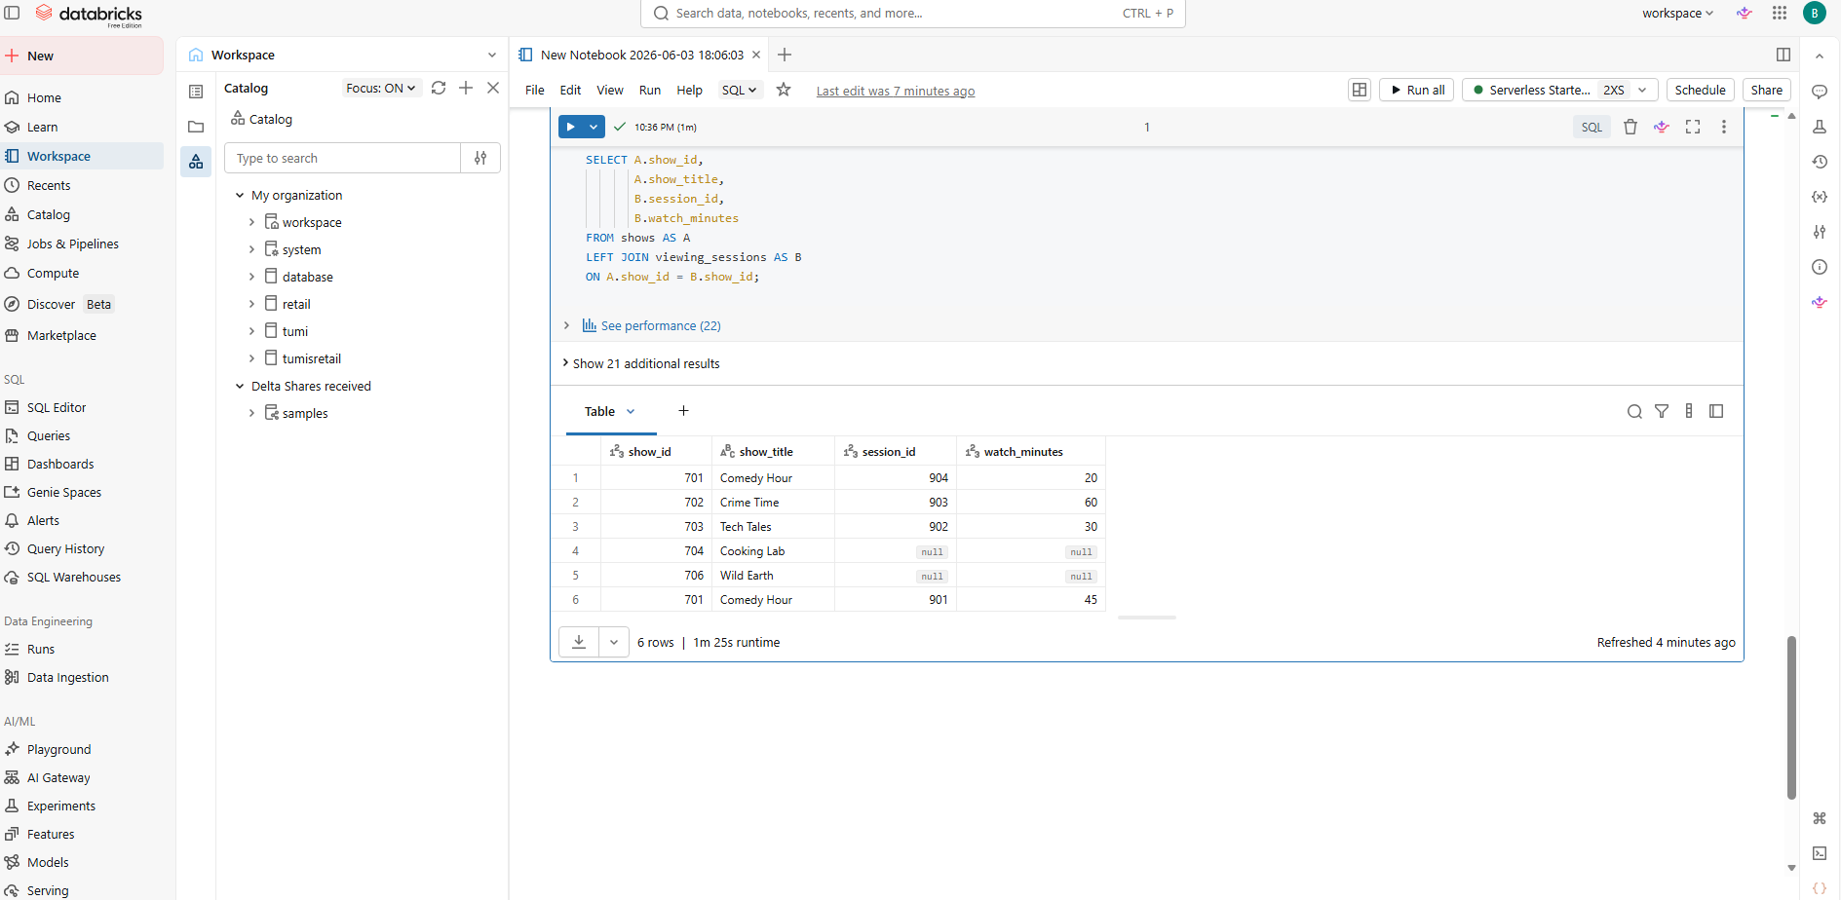
Table 8 shows all the shows even the ones that does not have viewing sessions. Show 704 and 706 were never watch hence they show NULL in the table.
Questions 9
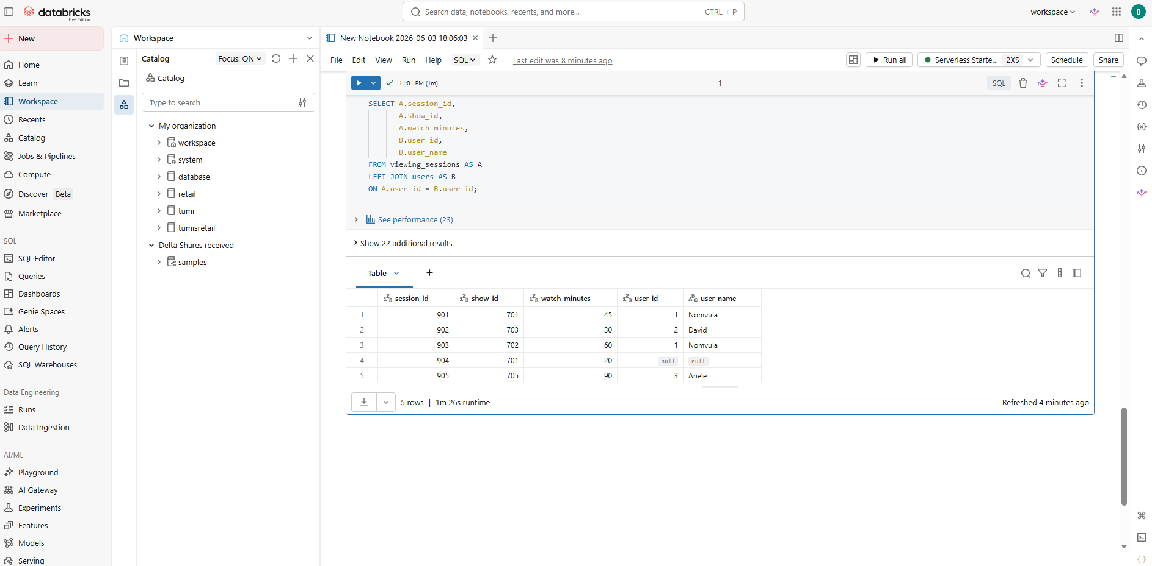
Table 9 shows every viewing sessions and their users who watched it. There is a user that has referencing sessions but is not included in the users table, they show NULL.

Question 10
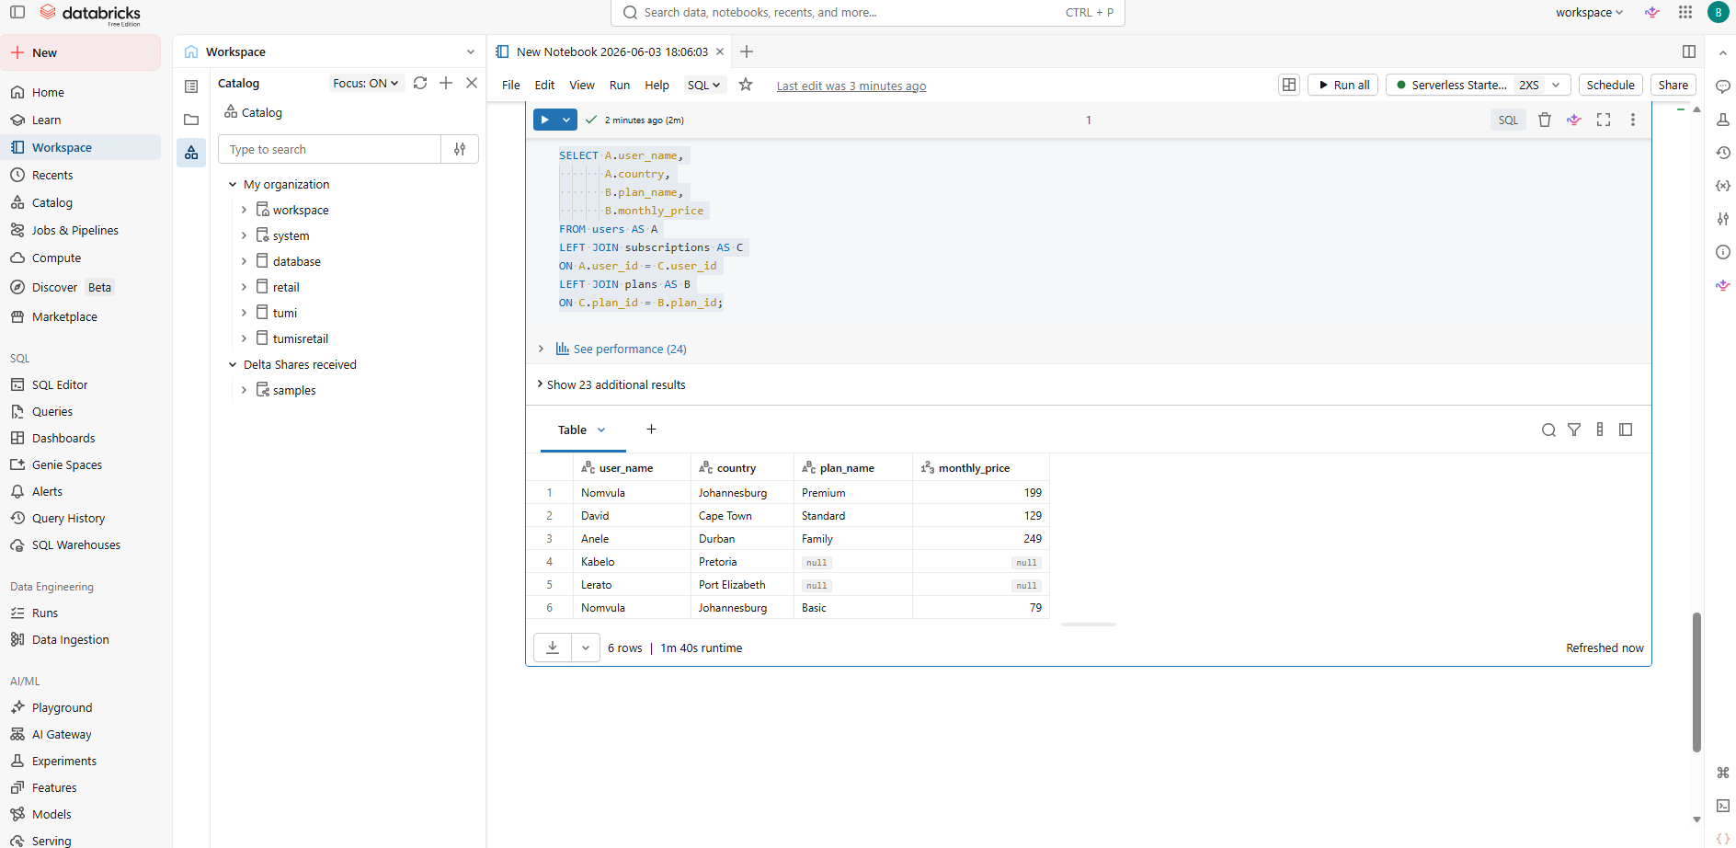
Table 10 shows all the users with their plans and the prices, the table includes all the users even if they don’t have subscription plans and they show NULL for the plan name and monthly price.
PART C
FULL OUTER JOIN
Question 11
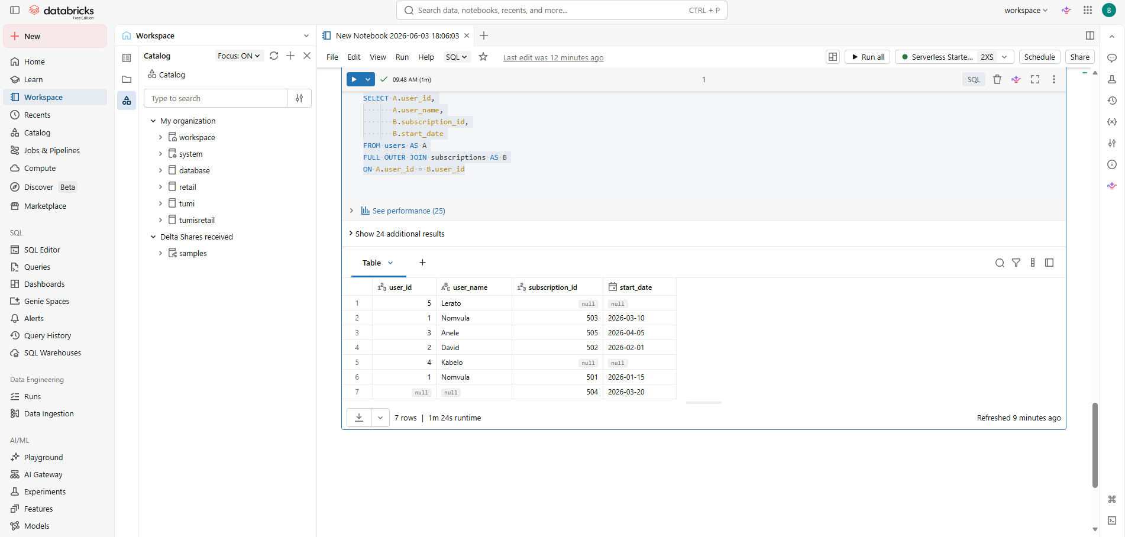
Table 11 shows all the users with their subscription plans and subscriber that does not have a user id. The users that don’t have subscription show NULL for subscription id and start date while the subscriber that does not have a user id shows NULL for user id and user name.
Question 12
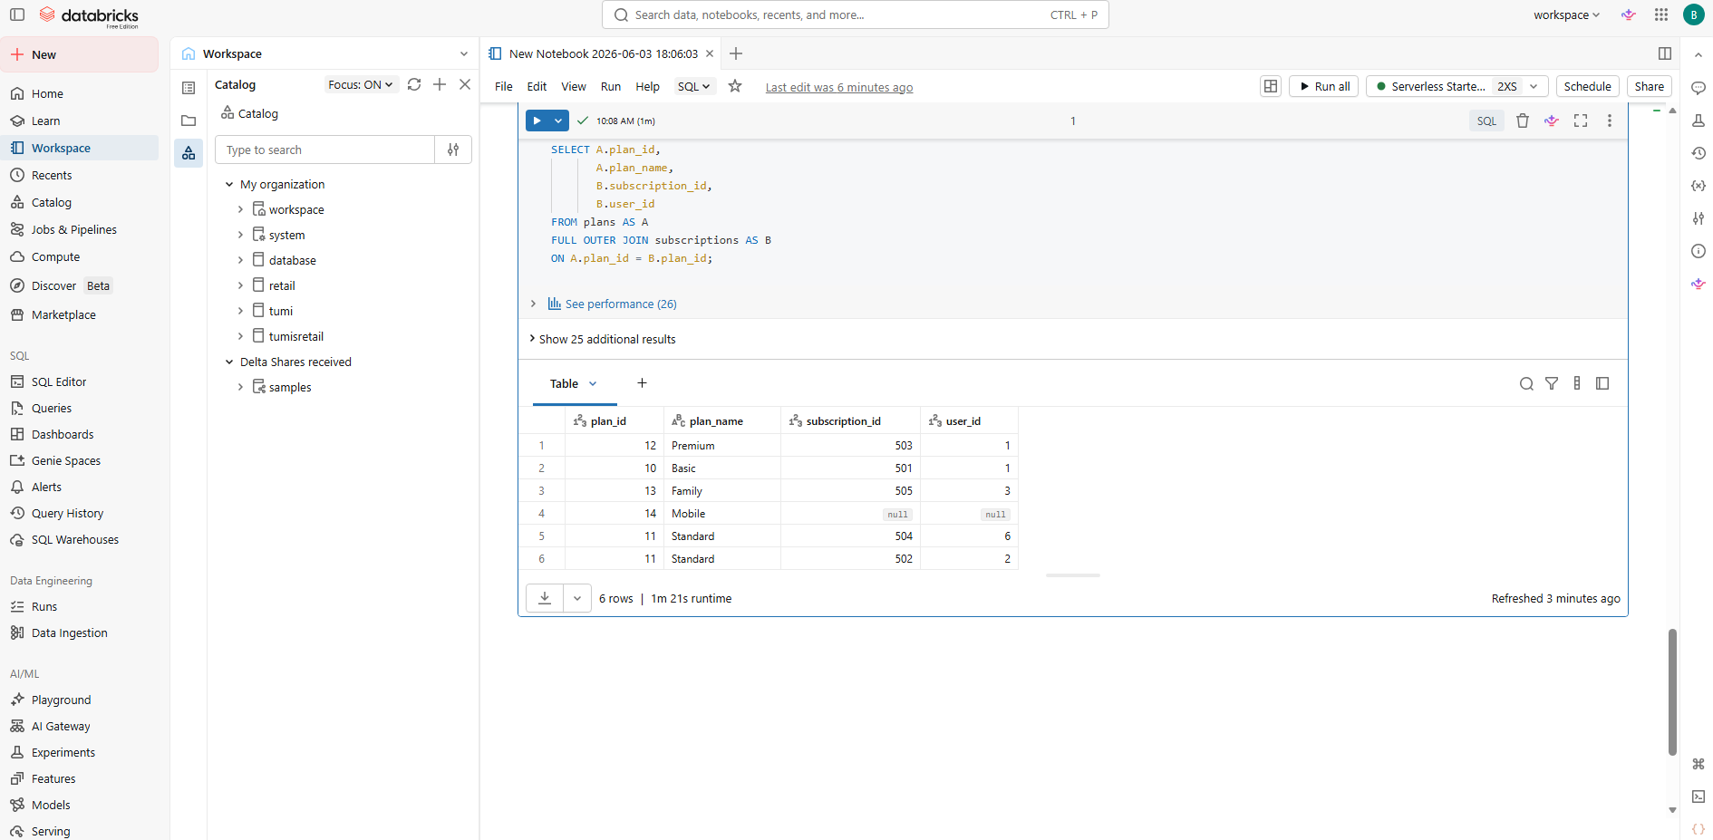
Table 12 shows all the plans and subscribers they have even the plan that does not have subscribers. Plan 14 show NULL for subscription id and user id because it has no subscribers.
Question 13
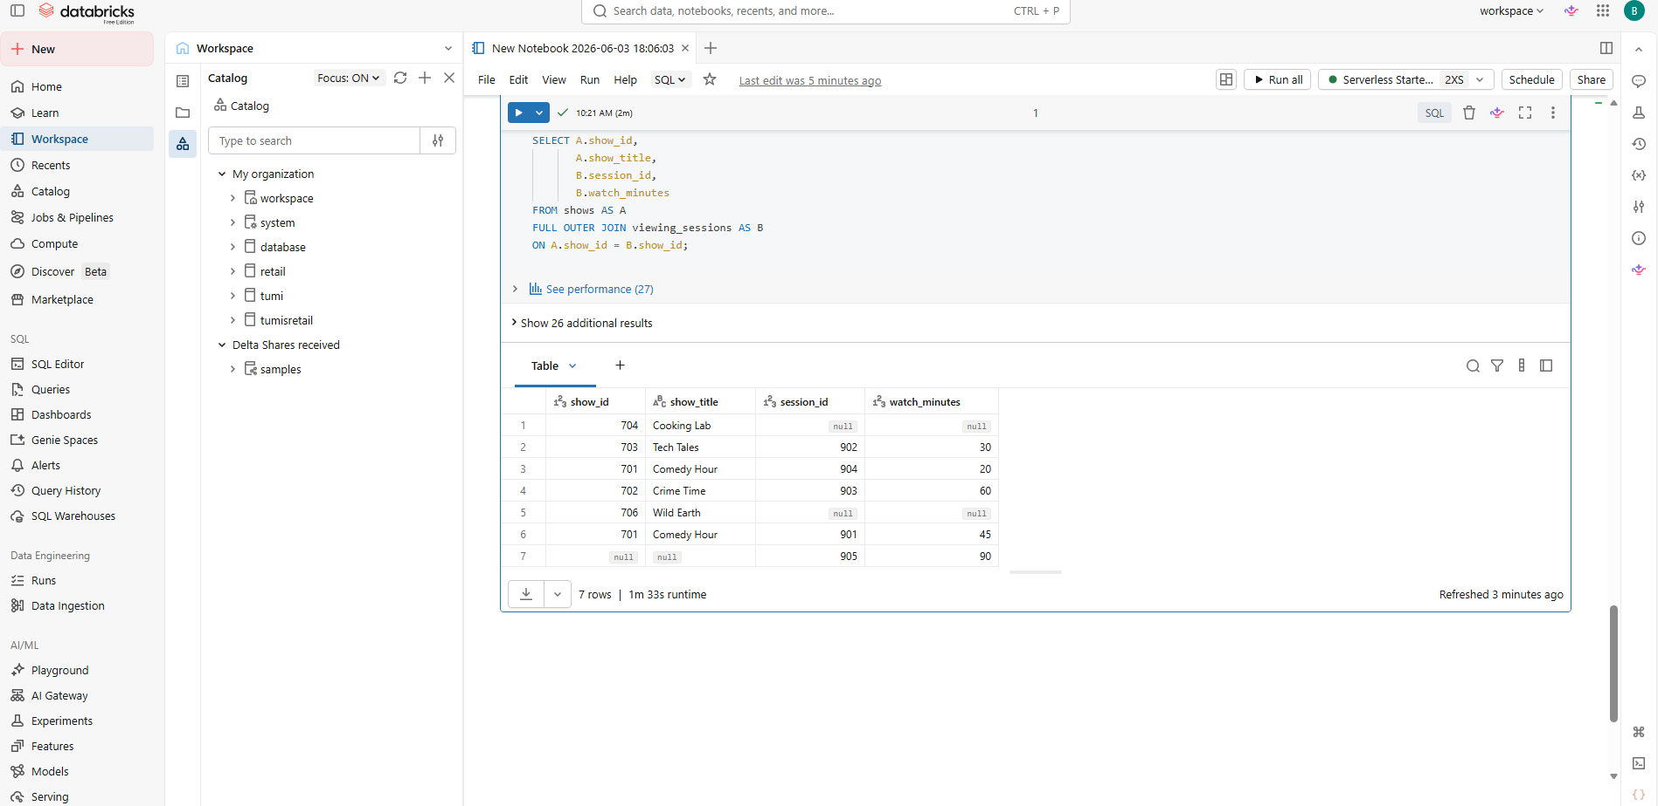
Table 13 shows all the shows and their viewing sessions even the shows that do not have viewing sessions like Cooking Lab and Wild Earth. It also includes sessions referencing shows that do not exist like session 905.

Question 14
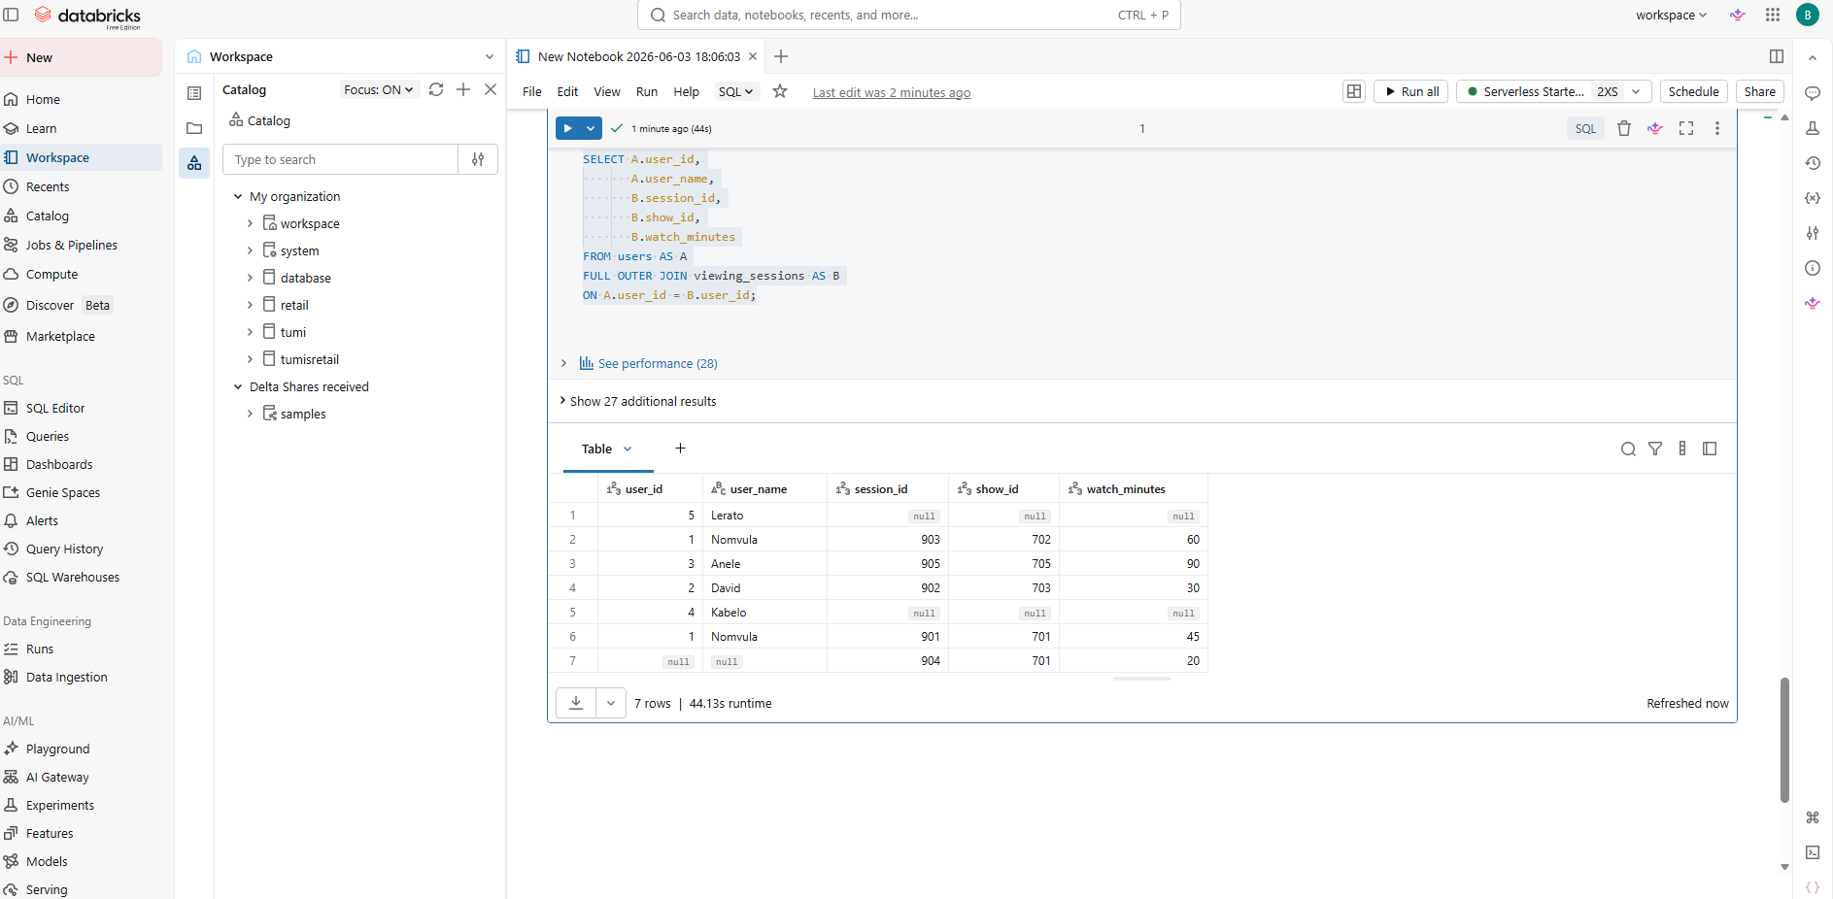
Table 14 shows all the users and their viewing sessions and even the ones without watching minutes as well as sessions referencing users without user id.
Question 15
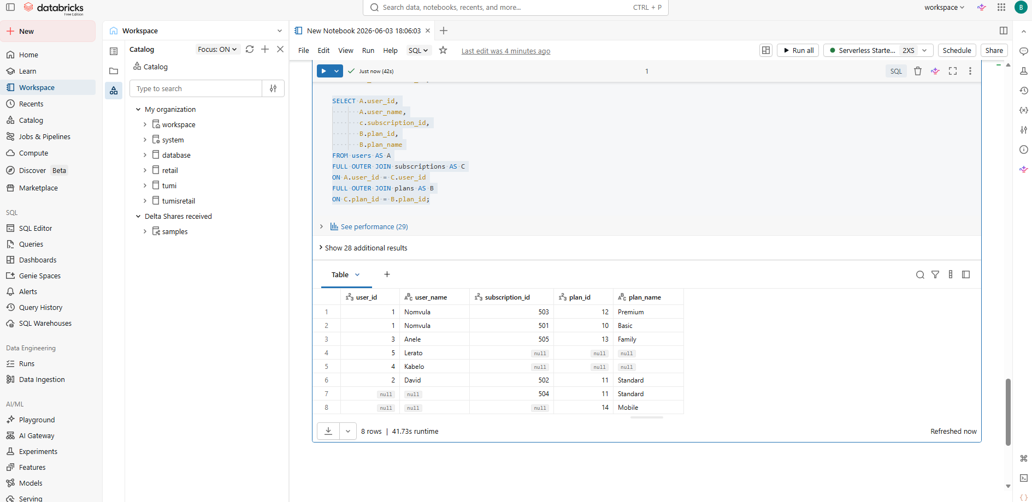
Table 15 shows all the users with or without plans and their respective subscription id, plan id and plan name. The users with plans show NULL and a subscription id and plan without users like subscription id 504 and a plan does not have subscribers like plan id 14 and both show NULL where there is no information.

BONUS QUESTIONS
1. User 4 (Kabelo) and user 5 (Lerato) never subscribed for any plan
2. Subscription_id 504 references user 6
3. Show 704 (cooking Lab) and show 706 (Wild Earth) have never been watched
4. Session 905 shows 705 does not exist
5. Plan 14 (Mobile) has no subscribers

